**Description**

1. Name ___________________________________________2. Sex________3. Village____________________

4. Main operational trading center _______________________5. Cell phone (1)________________

6. Cell phone (2) ____________________________7. Age__________

8. No. years of schooling (1= No schooling, 2= Primary, 3=Secondary, 4= Post-secondary): _____

**A. VC position**

|  |  |  |  |  |
| --- | --- | --- | --- | --- |
| Specify animal type (goat, sheep, cattle, fish) | 1. Live animals or fish | 1. Fresh milk, fresh or frozen meat or fish | 1. Processed products | |
| Activity | Product (enter code for each activity using codes in annex) |
| ______________ | * BUY * SELL (NOT TO CONSUMER) * PROCESS * SELL TO CONSUMER | * BUY * SELL (NOT TO CONSUMER) * PROCESS * SELL TO CONSUMER | * BUY * SELL (NOT TO CONSUMER) * PROCESS * SELL TO CONSUMER | * Use product codes (box), e.g. 1,3 * . * . * . |
| _____________ | * BUY * SELL (NOT TO CONSUMER) * PROCESS * SELL TO CONSUMER | * BUY * SELL (NOT TO CONSUMER) * PROCESS * SELL TO CONSUMER | * BUY * SELL (NOT TO CONSUMER) * PROCESS * SELL TO CONSUMER |  |
| _____________ | * BUY * SELL (NOT TO CONSUMER) * PROCESS * SELL TO CONSUMER | * BUY * SELL (NOT TO CONSUMER) * PROCESS * SELL TO CONSUMER | * BUY * SELL (NOT TO CONSUMER) * PROCESS * SELL TO CONSUMER |  |
| 1. Milk and dairy | * BUY * SELL (NOT TO CONSUMER) * PROCESS * SELL TO CONSUMER | * BUY * SELL (NOT TO CONSUMER) * PROCESS * SELL TO CONSUMER | * BUY * SELL (NOT TO CONSUMER) * PROCESS * SELL TO CONSUMER |  |

**Other business (TICK)**

|  |  |  |  |  |  |
| --- | --- | --- | --- | --- | --- |
| Operating a restaurant |  | Supply of inputs/services to producers (feeds, chemicals, medicine, credit, ice for storage, transport). |  | Sale of non-food consumer goods |  |
| Processing – (e.g. slaughter, filleting, dairy processing, fish drying/smoking) |  | Business related to crops |  | Animal production |  |

**B. CHAIN ACTORS**: The charts below should be filled in for the target commodity only. If the trader is buying / selling more than one product type (e.g. live animals and fresh meat), then separate charts should be completed for each product type. For each supplier type, specify the amount purchased during the peak season and the low season (using appropriate units, e.g. kg/week, animals/month) as well as the overall annual amount.

PRODUCT TYPE:___________________________________

Below is a chart of possible ***suppliers*** that you may have bought from last ***year***.

**5. Other______________**

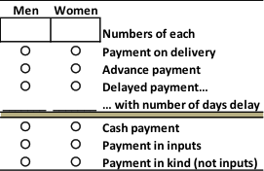

**4. Collectors/traders**



Volumes/yr.:

Units _________________

1. **Small producer**



Peak:

Low:

Annual: ____/yr

**7. Other:**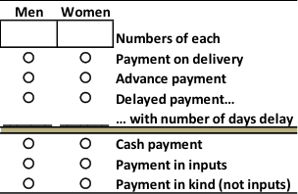

**2. Large producer**

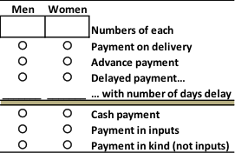

**6. You as a buyer**

**3. Producer group**

How has you number of suppliers changed in the last 5 years?

|  |  |  |
| --- | --- | --- |
| **Supplier Type** | **Change in number of suppliers (code)** | **If change, explain why?** |
| Small producers / farmers |  |  |
| Large producers / farmers |  |  |
| Producer Group |  |  |
| Traders |  |  |
| Processors |  |  |
| Other (specify: __________________) |  |  |
| 1 = Decreased, 2 = No change, 3 = Increased | | |

How have you volumes purchased from suppliers changed in the last 5 years?

|  |  |  |  |
| --- | --- | --- | --- |
| **Supplier Type** | **Annual (code)** | **Peak (code)** | **Low (code)** |
| Small producers / farmers |  |  |  |
| Large producers / farmers |  |  |  |
| Producer Group |  |  |  |
| Traders |  |  |  |
| Processors |  |  |  |
| Other (specify: __________________) |  |  |  |
| 1 = Decreased, 2 = No change, 3 = Increased | | | |

Below is a chart of possible ***buyers*** that you may have sold to ***last year***

**12. Final Consumers:**



**Food service establishments (prepared meat)**

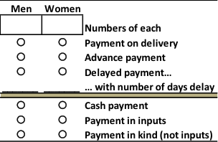

Specify unit:

______ / _____

Volumes/yr.:

Units _________________

**13. Traders**





**14. Retailers/butchers (raw meat)**

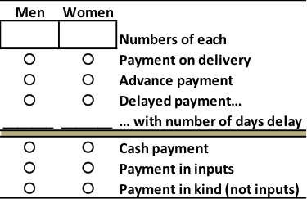

**10. You as a seller**





**11. Other__________________**

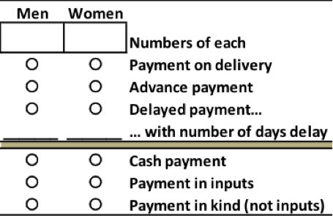

**15. Other:**

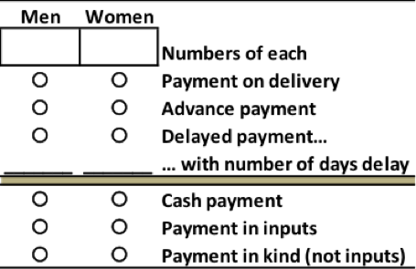

How has your number of buyers changed in the last 5 years?

|  |  |  |
| --- | --- | --- |
| **Buyer Type** | **Change in number of buyers (code)** | **If change, explain why?** |
| Small producers / farmers |  |  |
| Large producers / farmers |  |  |
| Producer Group |  |  |
| Traders |  |  |
| Processors |  |  |
| Other (specify: __________________) |  |  |
| 1 = Decreased, 2 = No change, 3 = Increased | | |

How have your volumes sold to buyers changed in the last 5 years?

|  |  |  |  |
| --- | --- | --- | --- |
| **Buyer Type** | **Annual (code)** | **Peak (code)** | **Low (code)** |
| Small producers / farmers |  |  |  |
| Large producers / farmers |  |  |  |
| Producer Group |  |  |  |
| Traders |  |  |  |
| Processors |  |  |  |
| Other (specify: __________________) |  |  |  |
| 1 = Decreased, 2 = No change, 3 = Increased | | | |

What is your approximate turnover per year? *(this means the sum total of all sales of all products and services)* (Currency)________ _______________________

**C. Processing activities for focus commodity**

|  |  |  |  |  |  |  |  |  |
| --- | --- | --- | --- | --- | --- | --- | --- | --- |
| **Processing activity** | **Which are you financially involved? Tick** | **What equipment do you own?** | **Approx. age of equipment (years)** | **Approx. value of equipment** | **Other inputs used for processing (packaging, cultures, ice, chemicals)** | **Actual amount processed Per day** | **Approx. cost of other inputs per day** | **Capacity of equipment available** |
| 1. Slaughtering |  |  |  |  |  |  |  |  |
| 1. Cutting / cleaning |  |  |  |  |  |  |  |  |
| 1. Curing/drying/smoking |  |  |  |  |  |  |  |  |
| 1. Pasteurization |  |  |  |  |  |  |  |  |
| 1. Fermentation |  |  |  |  |  |  |  |  |
| 1. Cold storage |  |  |  |  |  |  |  |  |
| 1. Freezing |  |  |  |  |  |  |  |  |
| 1. Hide Processing |  |  |  |  |  |  |  |  |
|  |  |  |  |  |  |  |  |  |

|  |  |
| --- | --- |
|  |  |

1. Is there any inspection for the processing activities? Yes / No
2. If yes, at what stages?
3. Who pays for inspections?
4. How much does the inspection cost? (currency)

**E. Sales and cost**

|  |  |
| --- | --- |
| 1. What is your approximate turnover per year?  (this means the sum total of all sales of all products) (Currency) |  |
| 2.What is the share of L&F products? |  |
| 2. What is your approximate total cost per year?  *(Compared to 5 yrs. Ago is it decreasing, increasing, same)* (Currency) |  |
| 3. What is the estimated share of L&F costs of total store/processor costs? |  |
| 4. Did the sales volumes and prices vary by quality category? |  |

**F. Transport and storage**

Do you own your own means of transport for this business? Yes/No

If Yes, what type _________________________________________________

[1=hand/animal cart; 2=bicycle; 3=scooter/motorbike; 4=small; vehicle 5=lorry; other=6______]

When buying…

|  |  |  |  |  |  |
| --- | --- | --- | --- | --- | --- |
| Supplier | Where is the place of purchase? (use codes)  1 Farm gate  2 At roadside  3 In a market  4 At your place  9 Other | 3.  What is the mode of transport  (use codes)  1=trekking  2=hand/animal cart  3=bicycle  4=scooter/motorbike  5=small vehicle  6=lorry | 4.  Who pays for transport?  (use codes)  1=seller  2=you as buyer  3=shared costs | 5.  What is the typical distance? (km) | 6.  What is the typical cost for one return trip?  Currency:  __________ |
|  |  |  |  |  |  |
|  |  |  |  |  |  |
|  |  |  |  |  |  |
|  |  |  |  |  |  |
|  |  |  |  |  |  |

What is the average time lag between buying and processing? (Indicate time unit: hours / days / weeks / months)

_______________________________

1. Do you have housing and feed available to keep animals between purchase and processing? Yes/No if Yes describe ___________________________________________________________________

When selling...

|  |  |  |  |  |  |
| --- | --- | --- | --- | --- | --- |
| 6. Buyer | 7.  Where is the place of sale? (use codes)  1 Farm gate  2 At roadside  3 In a market  4 At your place  5 At buyers place  9 Other | What is the mode of transport  (use codes)  1=trekking  2=hand/animal cart  3=bicycle  4=scooter/motorbike  5=small vehicle  6=lorry | Who pays for transport?  (use codes)  1=you as seller  2=buyer  3=shared costs | 10.  What is the typical distance? (km) | 11.  What is the typical cost for one return trip?  Currency:  __________ |
|  |  |  |  |  |  |
|  |  |  |  |  |  |
|  |  |  |  |  |  |
|  |  |  |  |  |  |
|  |  |  |  |  |  |
|  |  |  |  |  |  |

**G. EMPLOYEES /LABOUR**

How many employees do you employ?

|  |  |  |  |  |  |  |
| --- | --- | --- | --- | --- | --- | --- |
| **Employment status** | **Status** | **(i)Sex** | **(ii) Number of employees** | **(iii)Average monthly wage rate** | **(iv)Payment in Kind – indicate average local currency equivalent per month** | **Total annual**  **cost** |
| 1. Non-managerial (i.e. appropriate for a poor person) | Part-time | Male |  |  |  |  |
| Female |  |  |  |  |
| Full-time | Male |  |  |  |  |
| Female |  |  |  |  |
| 1. Managerial level | Part-time | Male |  |  |  |  |
| Female |  |  |  |  |
| Full-time | Male |  |  |  |  |
| Female |  |  |  |  |
| 1. Family labor | Part-time | Male |  |  |  |  |
| Female |  |  |  |  |
| Full-time | Male |  |  |  |  |
| Female |  |  |  |  |

**H. Services and inputs –TO BE REVISED**

|  |  |  |  |  |
| --- | --- | --- | --- | --- |
|  | *(i)If you provide these services/inputs…* | |  | *(ii)If you use or provide these services/inputs…* |
| **Service or input** | (a) Which inputs or services do you sell? (tick) | Which inputs or services do you provide on credit basis | (b)Do you provide this to those you buy livestock/fish or products from?  (YES/NO) | Do you receive this from those you sell livestock/fish or products to?  (YES/NO) |
| 1. Crop inputs |  |  |  |  |
| 1. Feeds |  |  |  |  |
| Animal medicines and supplements  Fish treatments |  |  |  |  |
| 1. Breeding services |  |  |  |  |
| 1. Fish fry/seed |  |  |  |  |
| 1. Ice for fish preservation |  |  |  |  |
| 1. Credit |  |  |  |  |
| 1. Extension advice |  |  |  |  |

**Pricing – check this**

|  |  |
| --- | --- |
| 1. On average what is the number of times per month that you experience product delay (to buy and sell)? 13 |  |
| 2. Are product prices predetermined? | * Yes * No |
| How long does it take you to agree on a price with your supplier and buyer? 13 |  |
| 1. What type of certification is in place? 14 |  |
| 1. Are prices based on grades? 14 | * Yes * No |

1. **Innovation -** Relative to 5 years ago…

|  |  |  |  |
| --- | --- | --- | --- |
|  | (i)Description | (ii) Are you still using this new product / method at present? Yes/No | (iii)If no, why not? |
| 1.Which new products have you tried to sell in the past 5 years? |  |  |  |
| 2.Which new inputs have you tried to sell in the past 5 years? |  |  |  |
| 3.Which new methods have you tried for producing, measuring, handling, processing or packaging products or inputs in the past 5 years? |  |  |  |
| 4.Have you changed the way you organize your business? |  |  |  |
| 5.Have you changed the way you are buying or selling products or inputs |  |  |  |

**J. Quality:**

Are you aware of any official grading systems for the products that you buy/sell.

If yes, for which products, how many different grades are there?

|  |  |
| --- | --- |
| Product | Number of quality grades |
|  |  |
|  |  |

When purchasing, which quality attributes are important?

|  |  |  |  |  |  |  |
| --- | --- | --- | --- | --- | --- | --- |
|  | Tick all that you use to determine quality when purchasing | 2.  Do you pay more per unit, as a premium?  YES/NO | 3.  Do you pay less per unit, as a penalty?  YES/NO | 4.  Do you reject animals/products on this basis?  YES/NO | 5.  Means of quality testing or measurement (specify) | 6.  Does this characteristic contribute to official grading systems? YES/NO |
| **(i)Live animals/fish** | | | | |  |  |
| 1. Size |  |  |  |  |  |  |
| 1. Weight |  |  |  |  |  |  |
| 1. Age |  |  |  |  |  |  |
| 1. Sex |  |  |  |  |  |  |
| 1. Color |  |  |  |  |  |  |
| 1. Breed   (species of fish) |  |  |  |  |  |  |
| (g) Apparent health |  |  |  |  |  |  |
| (h) Information on vaccination/ treatment/health status |  |  |  |  |  |  |
| (i) Litter size |  |  |  |  |  |  |
|  |  |  |  |  |  |  |
| **(ii)Milk, meat, fish, processed products** | | | | |  |  |
| (a) Freshness |  |  |  |  |  |  |
| (b) Lack of adulteration |  |  |  |  |  |  |
| (c) Content of fat or protein |  |  |  |  |  |  |
| (d) Color |  |  |  |  |  |  |
| (e) Cleanliness |  |  |  |  |  |  |
| (f) Packaging |  |  |  |  |  |  |

If you use official quality grades, what proportions of your overall purchases and sales fall into the different grades?

|  |  |  |  |  |
| --- | --- | --- | --- | --- |
|  |  | Low quality grade | Medium quality grade | High quality grade |
| Product  ______________________ | When buying |  |  |  |
| When selling |  |  |  |
| Product  ______________________ | When buying |  |  |  |
| When selling |  |  |  |

**K. VC co-ordination**

**Describe the types of relationships that you have with different supplier types**

**[Restructure table – separate rows for relationship basis]**

|  |  |  |  |  |  |  |
| --- | --- | --- | --- | --- | --- | --- |
|  | | Small producer | Large producer | Producer group | Collectors / traders | Other________ |
| Length of trading relationship (years) | |  |  |  |  |  |
| Basis of relationship  (Yes/No) | Kinship |  |  |  |  |  |
| Repeat sales |  |  |  |  |  |
| Quality of product |  |  |  |  |  |
| Reliability |  |  |  |  |  |
| Flexibility in payment |  |  |  |  |  |
| Location/accessibility |  |  |  |  |  |
| Other _______ |  |  |  |  |  |
| Can you make advance requests for products (Yes/No) |  |  |  |  |  |  |
| Contractual relationship  1=no contract  2=customary contract  3=verbal contract  4=written contract |  |  |  |  |  |  |
| Technical assistance provided by you (yes/No) |  |  |  |  |  |  |
| Credit provided by you (yes/no) |  |  |  |  |  |  |
| Prior price determination (yes/no) |  |  |  |  |  |  |
| Frequency of interaction  1=daily  2=weekly  3=monthly  4=seasonally |  |  |  |  |  |  |

What are the advantages and disadvantages of buying from a producer group, association or co-operative?

|  |  |  |
| --- | --- | --- |
| (i) Advantages | (ii) Disadvantages | (iii) Other notes |
|  |  |  |
|  |  |  |

**L. Collective action**

1. Are you a member of a livestock/fish/trader/seller association? YES/NO

If YES, what are the benefits that you derive from membership?__________________________

Do you collaborate with other traders (whether association members or not) on:

|  |  |  |  |
| --- | --- | --- | --- |
| **Item** | (i)  OFTEN | (ii)  OCCASIONALLY | (iii)  NEVER |
| 1. Access to inputs or services |  |  |  |
| 1. Providing large product volumes to specific buyers |  |  |  |
| 1. Agreeing on prices paid or areas served |  |  |  |
| 1. Transport |  |  |  |
| 1. Agreeing on quality standards used |  |  |  |
| 1. Access to credit |  |  |  |
| 1. Price information |  |  |  |
| 1. Information on market conditions |  |  |  |

**M. OPPORTUNITIES AND CONSTRAINTS**

What is the SINGLE most important constraint to

|  |  |
| --- | --- |
|  | Constraint |
| 1. Successful purchase (quality, quantity, other? |  |
| 1. Successful sale (quality, quantity, other? |  |
| 1. Successful processing |  |
| 1. Your making more money from your livestock/fish/animal business |  |

What is the SINGLE most important opportunity to

|  |  |
| --- | --- |
|  | Opportunity |
| 1. Make more money from your livestock/fish/animal business |  |

1. To overcome the constraints, or exploit opportunities, what has been tried already (that has not been mentioned above in Innovation Section?

_________________________________________________________________________

_________________________________________________________________________

_________________________________________________________________________

_________________________________________________________________________

**ANNEX: Product**

**Draft codes for processed products (the list would have to be adapted to products available in the local value chain)**

1. Carcasses
2. Quarters
3. Fresh, deboned meat
4. Fresh, bone-in meat
5. Frozen, deboned meat
6. Frozen, bone-in meat
7. Raw Sausages
8. Cooked or packaged meat
9. Cooked sausages
10. Offal
11. Cured or dried products
12. Canned meat products
13. Ready to eat products
14. Fillets
15. Whole fresh fish
16. Frozen fish